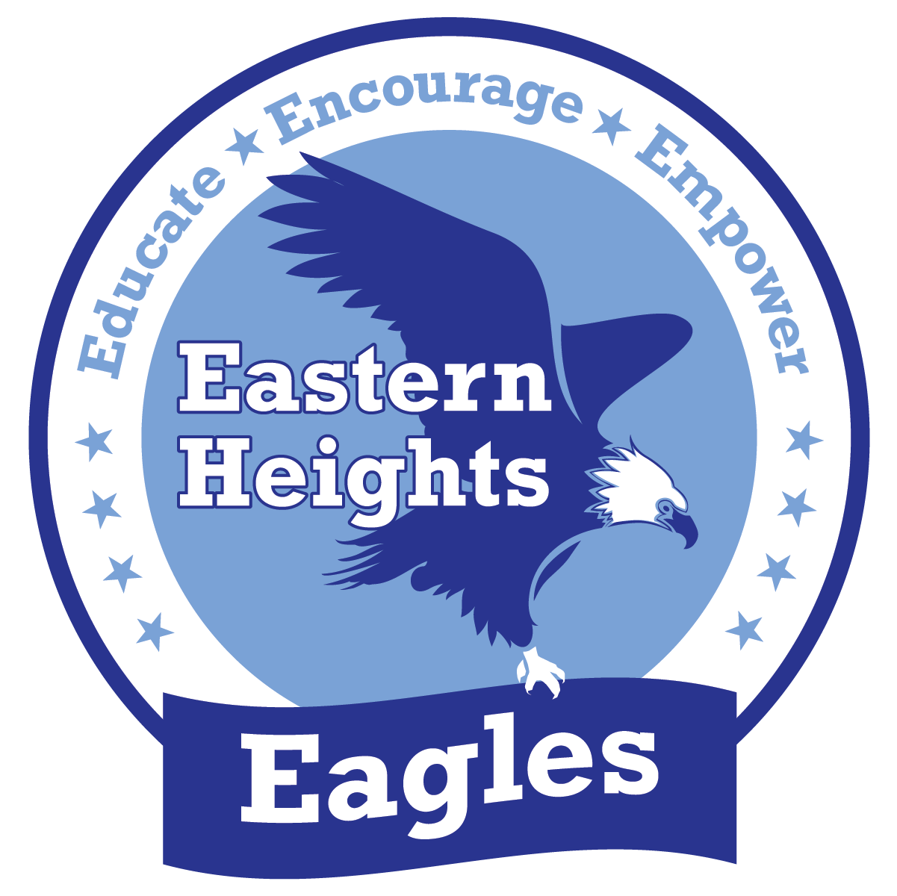 2023-24 Family Engagement Plan

Mission: Educate by creating a safe and equitable community through collaboration of students, families, and staff
Vision: As a community, we educate, encourage, and empower our students to be successful and respectful lifelong learners

The Family Engagement Plan (FEP) is organized into four impact areas. We will be working together this year to build positive and goal-oriented relationships in each area. Families and staff at school developed this plan together.

Welcoming Environment

Our school has staff member(s) available for families to discuss this plan and ask questions | - Principal: Susan Mondry  - Family Liaison: Isaias Menase  - Classroom and Specialist Teachers
Our school communicates with families in many ways. | - Student work and important information for families goes home in the weekly folder.  - Quarterly family newsletters  - Regular updates to the school website  - Parent/Teacher conferences  - APTT (Academic Parent Teacher Teams) meetings  - Weekly classroom newsletters  - Phone calls, emails, written letters, notes and flyers  Goal of a 24-hour response time to phone calls and voicemail messages
The achievement gap, or rather the “opportunity gap,” between students of color and white students in Saint Paul Public Schools is unacceptable. Our school is working to change practices and systems by identifying the barriers that make it harder for students of color to succeed and for their families to support their learning. | - For more about our work on racial equity, contact:  Susan Mondry, Principal or your child’s classroom teacher  - Leadership and Equity teams have been combined to  ensure equity is part of all leadership team discussions  and decision-making  - All licensed staff members have received racial equity training  - All staff members participate in training in the Restorative Practices model.
Transitions between schools can be challenging, and we work to help families as their children start and leave our school. | For new students and families, we support the transition by:  - We conduct an Open House in the fall for our new families (including Pre-K and K students) as an opportunity for students to meet their teachers and become more familiar with the school  - We also conduct Transition to Kindergarten programs for students and families in Spring, and Transitions to Middle School starting in January each year  - We invite students, families and staff from local feeder preschool programs such as Open Arms Preschool to visit Kindergarten classrooms in the spring.  For students and families moving to the next school in their pathway, we support the transition by:  - We collaborate with local middle schools to schedule visits and information sessions to assist our graduating students with transition to middle school.  - Students and staff from the local middle school visit Eastern Heights for a Q & A session with our current fifth graders.

Family Partnerships

Our school-parent compact establishes the shared responsibility for student success between the school, families, and students. Families and teachers work together to develop the compact. | - Copies of the compact are available: Copies of the compact are available to our families at our Fall Conference and on our school website at eastern.spps.org  - The compact is updated annually before the end of the previous school year and also in October prior to Conferences
There are many opportunities for families to build connections to the school and to each other. | - Title I Annual Meeting where we will share information about school programs will be conducted in September 2022  - Open House – September 1, 2022  - Grade Level Family Academic Information Nights re: Math and Literacy – Language Affinity Parent Groups – Primary & Intermediate - TBA  - Family/Community Carnival – Fall, 2022  - Multi-Cultural Arts Night – Winter, 2023  - School Choice Tours – Jan., Feb. 2023  - National African-American Parent Involvement Day (NAAPID) – Feb. 2023  - Family STEM Night – Spring, 2023  - Monthly parent and family engagement evening events  - Monthly Eagle Pride assemblies  - Families will be invited to be in partnership with staff in Culturally Relevant Instruction/ Academic Learning Events, and Family Partnership Decision-Making  - Family Seminars will be held in Language Affinity Groups multiple times throughout the year to provide opportunities for Parent Education, stakeholder input and feedback regarding school academic and other programs (i.e. PBIS, SAT, School Culture/ Climate, APTT, Listening sessions with Principal))  - Home Visits - Licensed and non-licensed staff will conduct Home Visits during the Summer and throughout the school year
We work to make these meetings and events available for every family in the school. | - Eastern Heights is a diverse school with many languages and cultures. All written materials sent to the home will be sent in English, Hmong, Spanish, Somali, and Karen. During meetings, we will provide translators.  - During monthly parent meetings, we provide childcare services and transportation to families that need to get to and from school after hours. Families needing transportation to conferences and other meetings should contact the School Office.  - We conduct personal phone calls to families of English learners. Bilingual staff provides interpreter services during meetings and via phone calls  - When sending out information, we create flyers in various home languages. We also use automatic phone calls to disseminate information  - Hmong, Spanish and Karen Speaking staff members assist  - During conferences, we offer families transportation or a virtual meeting option.  - During family events, we offer childcare, food and transportation as appropriate  - During large family events our family liaison is available to provide information about school activities  - Family Liaison staff invite parents to different family events  These strategies are in place to support families of ELL students.
Our school supports families as advocates and provides opportunities for parent leadership | • All licensed staff members have received racial equity training  • All staff members participate in training in the Restorative  Practices model  • All Staff participate in professional development in  Culturally Relevant Instruction and Partnerships for working  with our families  - Our school will conduct regular surveys of stakeholders and community partnership meetings to inform and be informed by parents and other community stakeholders.

Teaching and Learning

Our school shares information about state standards, assessment and student achievement with families in multiple ways | - Report cards and progress reports will be available on the Campus parent portal in conjunction with a Parent/Teacher Conference  - Parent-Teacher conferences are held twice a year in November and March (dates to be determined). Families may choose an in-person or virtual format.  - Our school shares information about student achievement with families in multiple ways.  - Our teachers participate in job-embedded Professional Development related to curriculum and instruction, and Professional Learning Communities (PLC) for progress monitoring and data analysis  - Report cards and progress reports will be distributed at Conference time by request.  - Parents will receive progress reports during conferences if requested.. Parent/Teacher conferences are held: November 2022 and March 2023  - Academic Parent Teacher Team meetings occur three times per year in certain classrooms.  - Parents will receive individualized progress reports upon request  - ACCESS scores for ELL students  - MCA Math/Reading scores for grades 3-5  - MCA Science scores grade 5  - During conferences, student results and data will be shared with families. Teachers will be able to share with families some strategies they can use at home to support student learning  - Our school will engage families in Personalized Learning as a key strategy to accelerate student achievement, as these changes come to our school  - Families will be provided with other website links and applications for use at home to reinforce concepts being taught at school  - When students are determined to not be performing at grade level, classroom teachers are directed to meet with colleagues within the Student. Assistance Team (SAT), parents are parent of this process. SAT considers each child’s needs and recommends interventions that support the student in achieving academic and/or behavioral standards  - Families will be invited to be in partnership with staff in Culturally Relevant Instruction/ Academic Learning Events, and Family Partnership Decision-Making  - Family Night and Seminars will be held in Language Affinity Groups multiple times throughout the year to provide opportunities for Parent Education, stakeholder input and feedback regarding school academic and other programs (i.e. PBIS, SAT, School Culture/ Climate)  - Families are encouraged to be in partnership especially to support Literacy Acquisition. Grade-Level Family Literacy Nights are planned to focus on educating and modeling strategies for parents.
Our school will engage in personalized learning as a key strategy to accelerate student achievement. Parents can get more information using many tools. | - Parent log-in information can be accessed at spps.org/onestop or by asking the school clerk  - iPads – Using the communication platforms of Schoology, Seesaw and Google Meets, parents will be informed about expectations, methods of instruction and curriculum. These platforms are effective in also gathering feedback.  - Schoology and/or Seesaw – provide information about the use of these learning management systems at your school
Many before- and after-school enrichment and support opportunities are available for students | • Eastern Heights offers an after-school Extended Day for Learning  (EDL) program two afternoons per week and EDL+ program one day per week without transportation provided.

Community Partnerships

Our school develops community partnerships to provide additional support for students and their families | - Sanneh Foundation – Conway Recreation Center  - Speaking Out  - Kids in Need  - Ecolab  - Dodge Nature Center  - Minnesota Orchestra  - Saint Paul Chamber Orchestra – CONNECT program  - Junior Achievement – BizTown  - Innocent Classroom Project  - Minnesota Landscape Arboretum  - Minnesota Humanities Commission – Bdote project  - Eastern Heights Lutheran Church – Every Meal  - Hazel Park United Church of Christ – Every Meal  - Holy Apostle Episcopal Church – Every Meal  - Starbase  - Heart of Dance  - 3M  - Legal Rights Center  - Dispute Resolution Center  - Southeast St Paul Early Learning Coalition  - Sunray Library  - McKnight Foundation

This plan is available as part of our school’s SCIP, or School Comprehensive Improvement Plan at spps.org/scip, is on our school website at eastern.spps.org, and printed copies are available in the office.

