I raise my hand to ask for help.

I run to the front of the line so I can eat first.

I clean up after

myself when lunch is over. 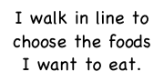

I take food off of

my friend’s tray and eat it.

I talk with my

friends sitting near me using an indoor voice.

I talk with my

friends near me using an

using an inside voice .

I walk in line to

choose the foods I want to eat.

My Lunch Tray of GOOD Choices!