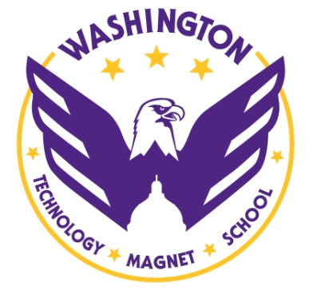
.
COURSE SEQUENCE OVERVIEW from Grades 6 to 12
The following chart provides an overview of the course options available to Washington students from 6th through 12th grade. Courses are sequential: building on the learning from one year to the next. These courses will ensure that students earn the credits they need to graduate from high school and be well-prepared for success in college and career.

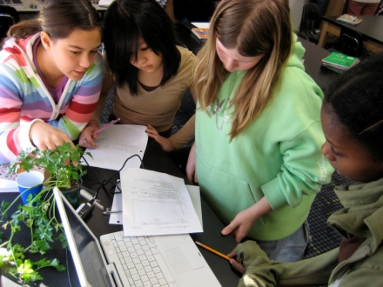
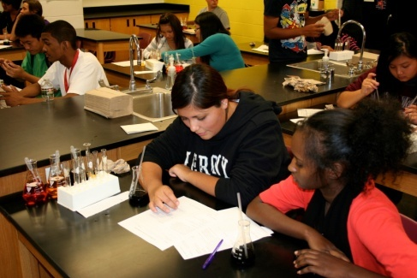

ACADEMIC AREAS | 6th GRADE | 7th Grade | 8th Grade | 9th Grade | 10th Grade | 11th Grade | 12th Grade | Ready for COLLEGE AND CAREER!
Science  BioSMART  Signature Course | Physical Science  OR  Accelerated Physical Science  Computer Applications Class | Life Science  OR  Accelerated Life Science  Health and Human Biology | Earth Science  OR  Accelerated Earth Science  Gateway to Engineering | Conceptual Physics  OR  Accelerated Conceptual Physics  Cell Biology and Advanced Earth Science | Chemistry  OR  Accelerated Chemistry  Health (emphasizing Anatomy & Physiology) | Biology  OR  Advanced Placement Biology | Science Electives:  • Physics  • Advanced Placement Chemistry  • Anatomy & Physiology  College in the Schools  • Forensics
 |  | BioSMART*: In 10th grade, all students choose a  BioSMART Pathway (Biomedical or Engineering) and  take required pathway courses  (*Science, Mathematics, Academic Rigor and Technology) |  | Biomedical Pathway | Project Lead The Way:  Principles of Biomedical Science | Anatomy and Physiology | Genomics & Microbiology
 |  |  |  | Engineering Pathway | Project Lead The Way:  Introduction to Engineering and Design | Project Lead The Way:  Principles of Engineering | Project Lead The Way:  Civil Engineering Architecture
Math | Math Foundations 6 | Pre Algebra Regular  OR | Algebra 1 (Regular)  OR | Intermediate Algebra (Regular)  OR | Geometry (Regular)  OR | Algebra 2 (Regular)  OR | Probability /Statistics & Pre-Calculus  OR
 |  | Pre-Algebra (Accelerated)  OR | Algebra 1 (Accelerated)  OR | Geometry (Accelerated)  OR | Algebra 2 (Accelerated)  OR | Probability /Statistics & Pre-Calculus  OR | Advanced Placement Statistics  OR
 | Pre-Algebra (Accelerated) | Algebra 1 (Accelerated) | Geometry (Accelerated) | Algebra 2 (Accelerated) | Probability /Statistics & Pre-Calculus | Advanced Placement Statistics  OR Advanced Placement Calculus | Advanced Placement Calculus
English | Reading 6  OR  Accelerated Language Arts | English 7  OR  Accelerated English 7 | English 8  OR  Accelerated English 8 | English 9  OR  Accelerated English 9 | English 10  OR  Accelerated English 10 | English 11  OR  Advanced Placement English Literature | English 12  OR  Advanced Placement English Composition
Reading (non-proficient) | Reading Support | Read 180 | Read 180 | Read 180 | Read 180 | GRAD Reading | GRAD Reading
Reading (partially proficient) | Reading Support | AMP Reading 7 | AMP Reading 8 | Reading Strategies | Advanced Reading Strategies | GRAD Reading | GRAD Reading
Social Studies | Minnesota History  OR Accelerated Minnesota History | American History  OR Accelerated American History | Global Studies  OR Accelerated Global Studies | World History  OR Accelerated World History | Human Geography  OR Advanced Placement  Human Geography | American History  OR Advanced Placement  American History | American Government / Economics  OR Advanced Placement  American Government
Physical Education  & Health | Physical Education 6 | Physical Education 7 | Physical Education 8 | Physical Education 9 | Fitness | Fitness | Fitness
 |  | Health and Human Biology |  |  | Health 10

MORE INFORMATION >
ACADEMIC AREAS | 6th GRADE | 7th Grade | 8th Grade | 9th Grade | 10th Grade | 11th Grade | 12th Grade | Ready for COLLEGE AND CAREER!
World  Languages | Sampler of Spanish, French, | Sampler of Spanish, French,  Hmong, and Chinese | Chinese 1 | Chinese 2 | Chinese 3 | Chinese 4 | Chinese 5
 | Hmong, and Chinese |  | French 1 | French 2 | French 3 | French 4 | French 5
 |  |  | Hmong 1 | Hmong 2 | Hmong 3 | Hmong 4 | Hmong 5
 |  |  | Spanish 1 | Spanish 2 | Spanish 3 | Spanish 4 | Spanish 5
Art | Visual Art | Art 1 | Art 1 | Visual Arts 1 | Visual Arts 1 | Visual Arts 2 | Visual Arts 2
 |  | Art and Business | Art and Business | Art and Business
 | Computer Applications | Digital Photography | Digital Photography | Beginning Photography | Advanced Photography | Advanced Photography | Advanced Photography
 | Computer Applications | Web Page Design | Web Page Design | Web Page Design | Advanced Web Design | Advanced Web Design | Advanced Web Design
Music | Extended Day Music Tech | Music Technology | Music Technology | Music Technology 2 | Music Technology 2 | Music Technology 2 | Music Technology 2
 | Introduction to Band | Beginning Band | Junior Varsity Band | Varsity Band | Concert Band | Concert Band | Concert Band
 | Introduction to Choir | Beginning Choir | Beginning Choir | Beginning Choir | Concert Choir | Concert Choir | Concert Choir
 | Introduction to Orchestra | Beginning Strings | Orchestra | Orchestra | Orchestra | Orchestra | Orchestra
Video Technology | Computer Applications | Digital Video Production | Digital Video Production | Technical Video Production | Technical Video Production | Technical Video Prod.2 | Technical Video Prod.2
Family & Consumer Science | Extended Day Clothing | Family and Consumer Science 1 | Clothing | Culinary Arts | Clothing 2 | Culinary Arts | Culinary Arts
 | Extended Day Foods | Foods | Child Development | Child Development 2 | Child Development 2 | Child Development 2 | Child Development 2
Naval JROTC | JROTC Fitness | JROTC Fitness | JROTC Fitness | Naval Science 1 | Naval Science 2 | Naval Science 3 | Naval Science 4
College Access:  Get Ready! | College and Career Workshops | Develop the Belief Workshops  All students visit the same college | Develop Understanding Workshops  Student choice of college visit | Academic Success Workshops  Four year private college visit | Career Exploration Workshops  Two year college visit | College Choice Workshops  College visits to colleges applying for | College and Financial Aid  Application and college acceptance
ATHLETICS | 6th GRADE | 7th Grade | 8th Grade | 9th Grade | 10th Grade | 11th Grade | 12th Grade
Soccer, Volleyball  Wrestling, Basketball | Club Level  Learning Basic Skills | Club Level  Learning Basic Skills | Middle School Competitive | Ninth Grade Competitive | Junior Varsity Competitive | Varsity Competitive | Varsity Competitive
Baseball, Softball  Track | Middle School Competitive | Middle School Competitive | Middle School Competitive | Junior Varsity Competitive | Junior Varsity Competitive | Varsity Competitive | Varsity Competitive
Swimming, Tennis | Club Level | Club Level | Club Level | Junior Varsity Competitive | Junior Varsity Competitive | Varsity Competitive | Varsity Competitive
Badminton | Club Badminton | Club Badminton | Middle School Competitive Badminton | Junior Varsity Competitive | Junior Varsity Competitive | Varsity Competitive | Varsity Competitive
Football | Club Level | Club Level | Middle School Competitive Flag Football | Junior Varsity Competitive Coop | Junior Varsity Competitive Coop | Varsity Competitive Coop | Varsity Competitive Coop
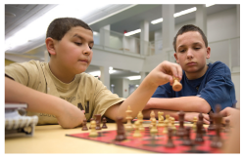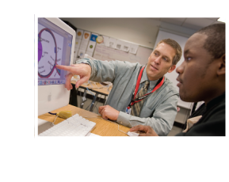
WASHINGTON TECHNOLOGY MAGNET | 1495 RICE STREET, SAINT PAUL, MN 55117 | 651-293-8830 | WASHINGTON.SPPS.ORG

