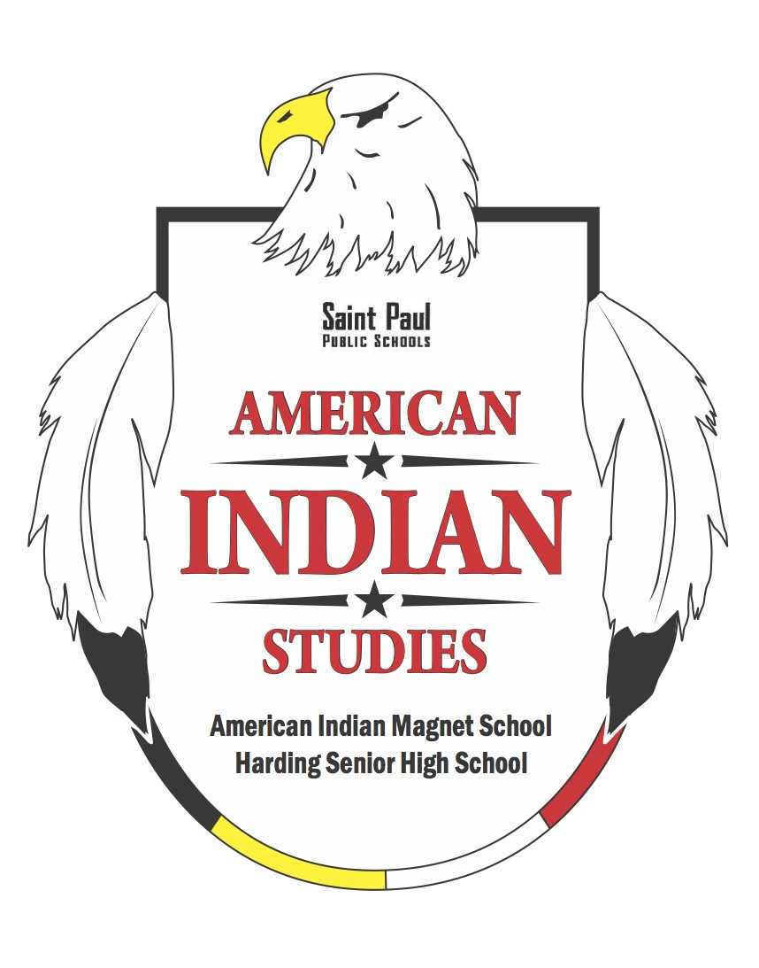
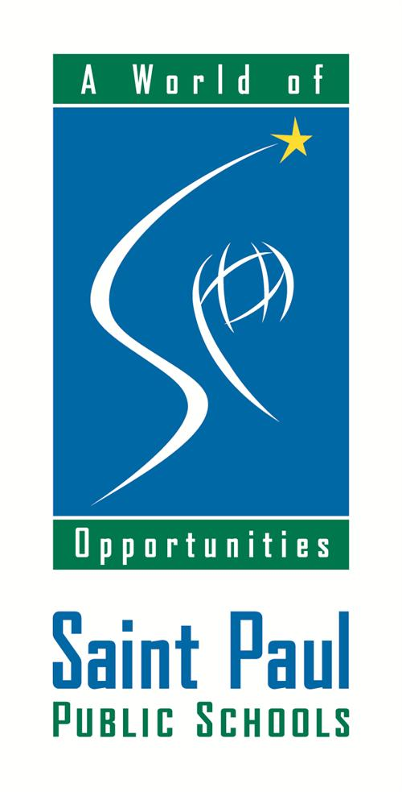
9/3/18
Boozhoo, Hau (Hello)! The American Indian Studies (AIS) Department would like to welcome all of our families back to school for the 2018-19 school year! The AIS staff at AIMS Middle School also wanted to update you all on some of the new things that are happening at AIMS this year.

The AIS program exists to teach ALL students about American Indian culture. This year we are really excited to be able to continue to bring to school many cultural resources, field trips, social events, storytelling events, and other community events. Please check the AIMS website for all upcoming events! aims.spps.org

Also, the AIS department would like to remind our families of the advantage of becoming part of the AIS family and that St. Paul Public Schools offers a “Distinction in American Indian Studies.” Much like college students choosing a major field of study, secondary students may choose to specialize in American Indian Studies. The path starts at American Indian Magnet School and continues on to Harding High School. Here are some of the things that AIS offers this year:

American Indian Magnet School (A pre-K through 8 School):
- D/Lakota and Ojibwe Language & Culture Class
- American Indian History
- Drum and Dance Class
- Native Cultural Infused Curriculum
- Powwows
- Woodland Culture Fair
- Plains Culture Fair
- All Indigenous Nations Fair
- Ojibwe and L/Dakota Language Quiz Bowls
- Indigenous AVID

Harding High School:
- Graduation with Distinctions in American Indian Studies
- The Braided Journeys Program
- Lakota Language & Culture Class
- Ojibwe Language & Culture Class
- Knowledge Bowls
- American Indian Literature
- American Indian History
- American Indian Art

American Indian AVID and SupportsAIS will continue on with an American Indian, culturally sensitive AVID (Advancement Via Individual Determination) implementation program (this year Harding is starting the high school version in 9th Grade!) that will focus on helping our students learn important skills to get to college while helping our students succeed in other aspects of their lives.

To ensure that learning continues, AIMS also has planned additional important information about things to know and prepare for this fall. As being a part of the SPPS community we would like to get to know our families better and it is very important to us that we find ways to communicate with each other to support your involvement in your child’s education.

The AIS department first believes in a quality education for all but also that we need to build on the cultural values that Native parents give their children and attempt to help the SPPS system to produce a strong positive sense of identity in their students. AIS stands to stop attempts to replace students' Native identity with a dominant cultural identity, which confuses and repels Native students and forces them make a choice to either reject their families' values or their teachers' values. Neither choice is desirable or necessary. Students can be academically successful and learn about the larger non-Native world while at the same time retaining and developing their Native identity. AIMS is the school where the Native cultural values are reinforced rather than ignored or depreciated. Our goal is to help all. We are looking forward to helping all of our students succeed this year!

AIMS, AIS Middle School Staff this year (Let us know if you have any questions):
- Jason Bresette – AIS Coordinator, AIS Teacher
- Niizhagabaw Wahpepah – Middle School Ojibwe Language and Culture Teacher
- Jim Thunderhawk – Middle School L/Dakota Language and Culture Teacher

Upcoming events:
- Eagle Feather Ceremony – September TBD
- Indian ED. Fall Feast and Drum Blessing at AIMS TBD
- Indigenous People’s Day Parade – October 8
- Ambassador Contest October
- First Drum and Dance practice September TBD @ 3:15 and continues every Friday
- Dakota/Lakota/Plains Nations Culture Fair December TBD

If you have any questions please do not hesitate to contact the AIS Coordinator, Jason Bresette. You can reach him at 651-744-6246 or Jason.bresette@spps.org. We are really excited to start the year and to continue on with our succeses.

