**Como Park Grill Fundraiser**

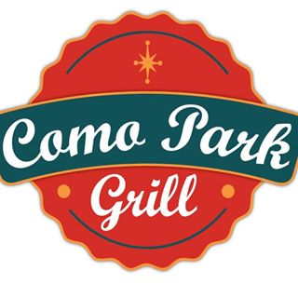

1341 Pascal Street St. Paul, MN 55108

“Fundraiser Night”

For Chelsea Heights Elementary School

Date_________ from 11:00 am-10:00pm

Bring this ticket in with you and present it when ordering

And **10%** of your total order will be donated to our group!

$ Amount of order: _________ Server Name ____________

**Como Park Grill Fundraiser**



1341 Pascal Street St. Paul, MN 55108

“Fundraiser Night”

For Chelsea Heights Elementary School

Date_________ from 11:00am-10:00pm

Bring this ticket in with you and present it when ordering

And **10%** of your total order will be donated to our group!

$ Amount of order: _________ Server Name ____________