**Parking:**

Parking in designated spots only please.

Please do not park or stop in the main driveway. This is the bus loading and unloading zone only.

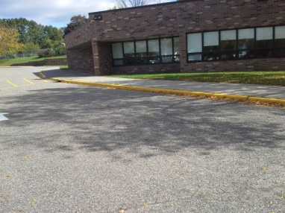 + C:\Program Files (x86)\Microsoft Office\MEDIA\CAGCAT10\j0183328.wmf = 

 +   