FREMONT ADULT SCHOOL
ESL DEPARTMENT CASAS LEVEL C PRACTICE TEST
(You will need to write your answers on a piece of paper.)
FACE/Rochelle Oral 2009
© 2008 SMART Technologies ULC. All rights reserved. The Senteo logo and the SMART logo are trademarks or registered trademarks of SMART Technologies ULC in the U.S. and/or other countries.
www.education.smarttech.com
1
. You want to live in a rental that has air
conditioning. Which telephone number should
you call?
A. 321­0945
B. 555­0022
C. 440­3300
D. 555­9873
2
. Which ad has 5 bedrooms?
A. Ad 1
B. Ad 2
C. Ad 3
D. Ad 4
Refer to the ads to answer the next two questions.
Ad #1
Fremont Hills Apartments
$1,500/mo., 1BR, 2BA,
A/C, Cable TV, Covered
Parking.
Call 555­0022 M­F, 9­5.
Ad #2
Sunnyside Apartments
&2 BR apts. w/ new
1
carpet, pool, no pets.
First month's rent is
free! Call 321­0945 bet
8
&5 or call 555­9873
after 5 PM.
Ad #3
Bella Luna Apartments
$1,250/mo., 2BR, 2BA,
nr shopping and BART.
Call 440­3300 8­4,
M­Th.
Ad #4
House for Rent
Lrg 5 BD, 3BA house
for rent, AEK, W/D, 2
car gar, lrg yd, call 339­
8233
M­F after 5PM.
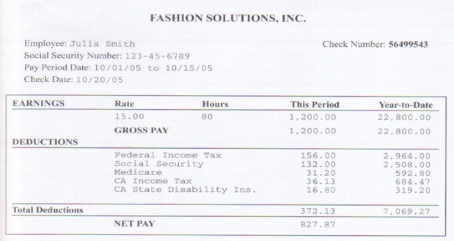
© 2008 SMART Technologies ULC. All rights reserved. The Senteo logo and the SMART logo are trademarks or registered trademarks of SMART Technologies ULC in the U.S. and/or other countries.
www.education.smarttech.com
3
. How many hours did Julia work during this
pay period?
A. 15
B. 80
C. 156
D. 1,200
4
. What was Julia's gross pay during this pay period?
A. $22,800.00
B.
$7,069.27
C.
$2,964.00
D.
$1,200.00
Study the wage stub to answer the next two questions.
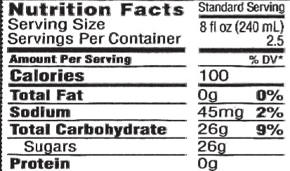
© 2008 SMART Technologies ULC. All rights reserved. The Senteo logo and the SMART logo are trademarks or registered trademarks of SMART Technologies ULC in the U.S. and/or other countries.
www.education.smarttech.com
5
. How many servings are in this bottle of soda?
A. 2.5
B. 8
C. 45
D. 100
6
. How many calories are in one serving of this
bottle of soda?
A. 8
B. 26
C. 45
D. 100
Directions: Refer to the soda bottle label to answer the next two questions.

Directions: Study the map to answer the next two questions.
 | 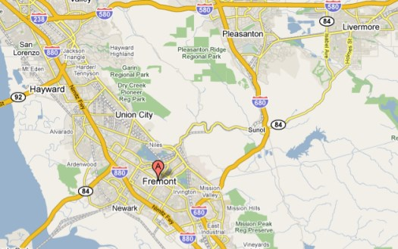
7. According to this map, Union City is:  - South of Fremont  - Southwest of Fremont  - Southeast of Fremont  - North of Fremont |  | 8. According to this map, the 680 Freeway goes through:  - Hayward  - Pleasanton  - Newark  - Livermore
© 2008 SMART Technologies ULC. All rights reserved. The Senteo logo and the SMART logo are trademarks or registered trademarks of SMART Technologies ULC in the U.S. and/or other countries.
www.education.smarttech.com

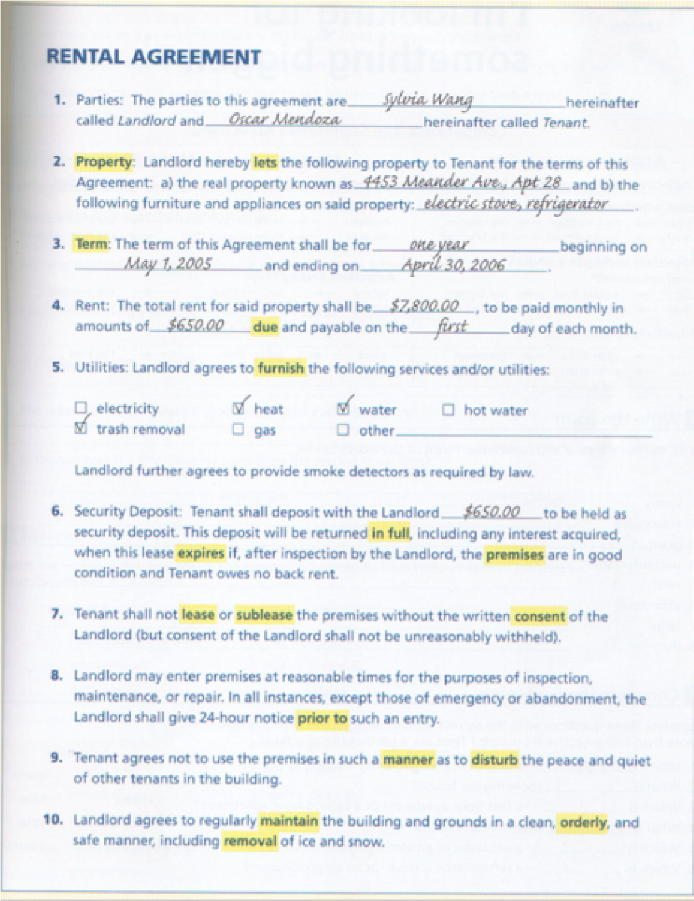  Directions: Refer to the rental agreement to answer the next three questions. | 9. How long is this rental agreement for?  - 1 year  - 1 month  - 6 months  - 2 years  10. What is a security deposit?  - The money you pay for your rent each month.  - The money the landlord holds until you move out. This money is returned to you if the apartment is in good condition when you move out.  - The money you pay for utilities.  - The money you pay if to the landlord to hold the apartment for you.  11. The landlord needs to enter your apartment to repair the refrigerator. How many hours notice must the landlord give?  - 6 hours  - 12 hours  - 18 hours  - 24 hours  www.education.smarttech.com
© 2008 SMART Technologies ULC. All rights reserved. The Senteo logo and the SMART logo are trademarks or registered trademarks of SMART Technologies ULC in the U.S. and/or other countries.

Read the information and answer the next three
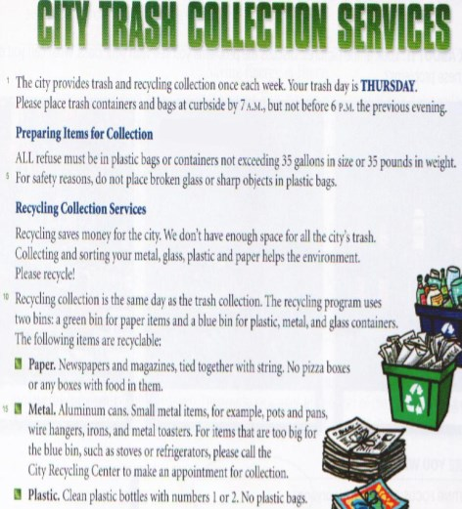 | questions.  12. The recycling program uses how many bins?  - 1  - 2  - 3  - 4
13. What time should you place trash containers curbside?
- After 7 AM, but not before 6 PM the previous evening.
- Before 6 PM the previous evening.
- By 7 AM, but not before 6 PM the previous evening.
- Two days before your collection day.
14. What should you do for large items, such as refrigerators, that are too big for the blue bin?
- Leave the items curbside without calling for an appointment for collection.
- Call the City Recycling Center to make an appointment for collection.
- Leave the items curbside and maybe if someone sees them, they will pick up the items. D. Try to fit the items in another bin.
www.education.smarttech.com
© 2008 SMART Technologies ULC. All rights reserved. The Senteo logo and the SMART logo are trademarks or registered trademarks of SMART Technologies ULC in the U.S. and/or other countries.

Directions: Refer to the employment application to answer the next two questions.
15. According to this application,
- Mary did not work for this company before.
- Mary graduated from college.
- Mary has excellent customer relation and telephone skills.
- Mary wants to work full­time.
16. According to this application, which sentence is correct?
- Mary can work Mondays from 4 PM to 9 PM.
- Mary can work Wednesdays from 3 PM to 9 PM.
- Mary can work Fridays 1 PM to 10 PM.
- Mary can work Saturdays 5 PM to 10 PM.

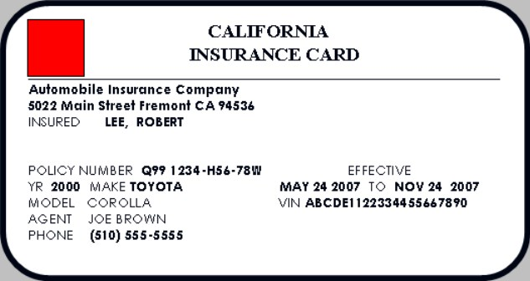
Directions: Refer to the automobile insurance card to answer the next two questions.
17
. What is the name of Robert's insurance company?
A. Lee's Insurance Company
B. Automobile Insurance Company
C. Joe Brown Insurance Company
D. Toyota Insurance Company
18
. How long is this policy in effect?
A. One year
B. Eight months
C. Six months
D. One month
Coverages
Bodily Injury Each Person $300,000
Property Damage Each Accident $75,000
Medical Payments Each Person $1,000
Uninsured Motor Vehicle $30,000

Directions: Refer to the charts
to answer the next 2 questions. | 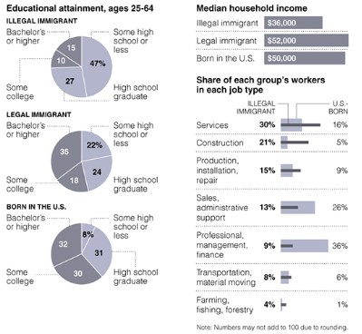
19. Looking at the "Educational Attainment" charts, what percent of people born in the U.S. are high school graduates?  - 8%  - 30%  - 31%  - 32%  © 2008 SMART Technologies ULC. All rights reserved. The Senteo logo and the SMART logo are trademarks or registered trademarks of SMART Technologies ULC in the U.S. and/or other countries. |  | 20. Looking at the "Share of Each Group's Workers in Each Job Type" charts, what percent of U.S. born workers are in the "Professional, Management, Finance" category?  - 5%  - 9%  - 26%  - 36%  www.education.smarttech.com

Read the business letter to answer the next two questions.
April 23, 2008
Mr. Jack Richmond
Customer Service Manager
Bank USA
555 Ocean Avenue
San Francisco, CA, 92223 Dear Mr. Richmond:
My name is Sara Lee, and I am a Bank USA customer. I am writing you about a problem with my checking account. My account number is 00­111­2222883. When I received my last checking account statement, I noticed that $500 had been withdrawn from my account on March 3, 2008 from an ATM in Los Angeles, California. I immediately called the bank on March 15, 2008. I spoke with Mary Delgado, the branch manager. I told her that I was not in Los Angeles on March 3, 2008. In fact, I have never been to Los Angeles. When I asked that the $500 be credited to my account, Ms. Delgado became very angry. She yelled at me on the telephone. She said that she did not believe that I was not in Los Angeles on March 3, 2008.
I am enclosing a copy of my checking account statement that shows the $500 withdrawal from my account. I am also enclosing a copy of a letter from my employer stating that I was at work in Fremont, California on March 3, 2008.
To resolve the problem, I am asking that the $500 be credited to my checking account within 14 days from receipt of this letter, or I will be closing my accounts with Bank USA and taking my money to another bank with better customer service and security.
In closing, I would like to say that I have been a customer at your bank for over 15 years, and I am very dissatisfied with your bank's customer service.
Sincerely, Sara Lee
Sara Lee
39922 Blacow Road
Fremont, CA, 94536
(510) 555­0033
21. In which paragraph does Sara state the problem?22. Where is the salutation of this letter written?
- 1A. It is written under the recipient's name and address.
- 2B. It is written at the end of the letter.
- 3C. It is written in paragraph 1.
- 4D. It is written above the date.

Attachments
rental agreement casas c.doc

